ASSIGNMENT-2

1)

i)code:

#include <stdio.h>

int main()

{

int a,b,c,max;

printf("enter three numbers\n");

scanf("%d%d%d",&a,&b,&c);

if(a>b)

{

if(a>c)

max=a;

else

max=c;

}

else

{

if(b>c)

max=b;

else

max=c;

}

printf("max number= %d",max);

return 0;

}

Output:

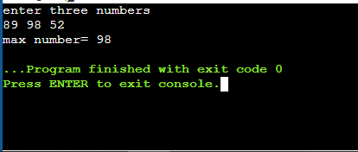

ii)

code:

#include <stdio.h>

int main()

{

int a,b,c,max;

printf("enter three numbers\n");

scanf("%d%d%d",&a,&b,&c);

max=(a>b)?(a>c)?a:(b>c)?b:c:c;

printf("max number= %d",max);

return 0;

}

Output:

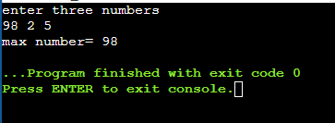

iii)

code:

#include <stdio.h>

int maximum(int a,int b,int c)

{

int max=a;

if(b>max)

max=b;

if(c>max)

max=c;

return max;

}

int main()

{

int a,b,c;

printf("enter three numbers\n");

scanf("%d%d%d",&a,&b,&c);

printf("max number= %d",maximum(a,b,c));

return 0;

}

Output:

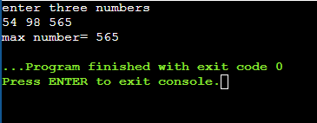

2)

Code:

Output:

3)

Code:

#include <stdio.h>

#include<string.h>

int main()

{

int n,k=0;

char a[50];

printf("enter the string\n");

scanf("%s",a);

n=strlen(a);

for(int i=0;i<=n/2;i++)

if(a[i]!=a[n-1-i])

{

k++;

break;

}

if(k==0)

printf("palindrome string");

else

printf("not palindrome");

}

Output:

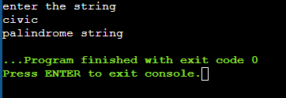

4)

Code:

//to find prime factors of given number

#include <stdio.h>

int main()

{

int num,a[20],i=2,k=0;

printf("enter number");

scanf("%d",&num);

while(num!=1)

{

while(num%i==0)

{

a[k++]=i;

num=num/i;

}

i++;

}

for(int j=0;j<k;j++)

printf("%d\t",a[j]);

}

Output:

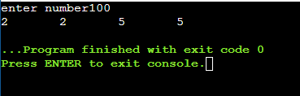

5)

Code:

#include <stdio.h>

int small(int a,int b,int c){

int min=a;

if(b<min)

min=b;

if(c<min)

min=c;

return min;

}

int large(int a,int b,int c){

int max=a;

if(b>max)

max=b;

if(c>max)

max=c;

return max;

}

int main()

{

char choice;

int a,b,c;

printf("enter 3 numbers");

scanf(" %d%d%d",&a,&b,&c);

printf("show three numbers(r)/calculate the total(t)/calculate the average(a)/display the smallest(s)/display the largest value(l)");

scanf(" %c",&choice);

switch(choice)

{

case 'r':printf("%d\n%d\n%d",a,b,c);

break;

case 's':printf("%d",small(a,b,c));

break;

case 'l':printf("%d",large(a,b,c));

break;

case 'a':printf("%f",(a+b+c)/3.0);

break;

case 't':printf("%d",a+b+c);

break;

default:printf("enter valid input");

}

}

Output:



6)

Code:

#include <stdio.h>

int main()

{

int i,num;

int stu[70],cie1[70],cie2[70],total[70],avg=0;

printf("total no of students are:\n");

scanf("%d",&num);

for(i=0;i<num;i++)

{

printf("enter student %d cie 1 and cie 2 marks\n",i+1);

scanf("%d%d",&cie1[i],&cie2[i]);

total[i]=cie1[i]+cie2[i];

avg+=total[i];

}

for(int j=0;j<i;j++)

{

printf("\nstudent%d marks in cie 1 is %d and in cie2 is %d\n and his total marks to be calculated is %.2f" ,j+1,cie1[j],cie2[j],(total[j])/2.0);

}

printf("\n class average is %.2f",avg/(2.0*i));

return 0;

}

Output:

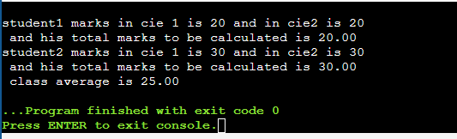

7)

Code:

#include<stdio.h>

#include<math.h>

int compound();

int main()

{

float interest;

interest=compound();

printf("\n interest is %.2f",interest);

}

int compound()

{

int p,t;

float r,c_int;

printf("\nenter the principal amount");

scanf("%d",&p);

printf("\nenter the rate and time");

scanf("%f%d",&r,&t);

c_int=(p*pow((1+(r/100)),t)-p);

return c_int;

}

Output:

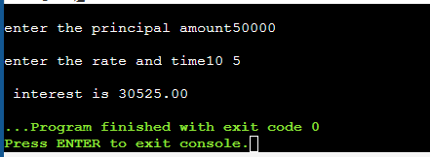

8) code:

Output:

9)

Code:

Output:

10)

a)

code:

#include <stdio.h>

int fibo(int);

int main()

{

int n,f;

printf("enter total terms upto which fibonacci is to be find\n");

scanf("%d",&n);

printf("\nfibonnaci series is\n");

for(int i=1;i<=n;i++)

printf("%d\t",fibo(i));

return 0;

}

int fibo(int n)

{

if(n==1)

return 0;

if(n==2)

return 1;

else

return fibo(n-2)+fibo(n-1);

}

output:

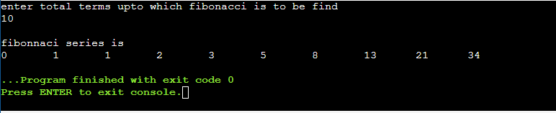

b)

Code:

#include<stdio.h>

int main()

{

int i,n,a[20];

printf("enter upto which terms to go in fibbonacci series");

scanf("%d",&n);

a[0]=0;

a[1]=1;

for(i=2;i<n;i++)

{

a[i]=a[i-2]+a[i-1];

}

for(int j=0;j<n;j++)

printf("%d ",a[j]);

}

Output:

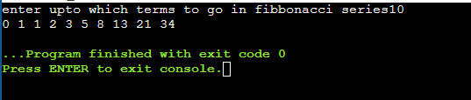

11)

Code:

Output:

12)

Code:

#include<stdio.h>

int main()

{

int a[10];

int n;

printf("enter size of array\n");

scanf("%d",&n);

printf("enter elements of array\n");

for(int i=0;i<n;i++)

scanf("%d",&a[i]);

for(int i=0;i<n-1;i++)

{

for(int j=i+1;j<n;j++)

{

while((a[i]==a[j])&&j<n)

{

for(int k=j;k<n-1;k++)

{

a[k]=a[k+1];

}

n--;

}

}

}

for(int i=0;i<n;i++)

printf("%d\t",a[i]);

}

Output:

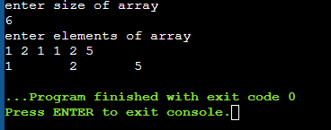

13)

Code:

#include<stdio.h>

int main()

{

int a[10][10];

int r,c,sum=0;

printf("enter rows and columns\n");

scanf("%d%d",&r,&c);

printf("enter elements of matrix\n");

for(int i=0;i<r;i++)

{

for(int j=0;j<c;j++)

scanf("%d",&a[i][j]);

}

for(int i=0;i<r;i++)

{

for(int j=0;j<c;j++)

{

if(a[i]==a[j])

{

sum+=a[i][i];

}

}

}

printf("\nsum of diagonal elements = %d",sum);

}

Output:

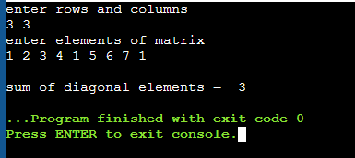

14)

Code:

#include<stdio.h>

int main()

{

float a[10],sum=0,mean;

int n;

printf("enter total numbers in array\n");

scanf("%d",&n);

printf("enter elements of array\n");

for(int i=0;i<n;i++)

{

scanf("%f",&a[i]);

sum+=a[i];

}

printf("\nmean of all array elements= %.2f",sum/n);

}

Output:

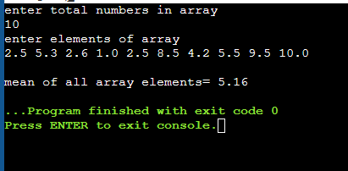

15)

Code:

#include<stdio.h>

int main()

{

int a[10][10],even[10],odd[10],k=0,p=0;

int r,c;

printf("enter rows and columns\n");

scanf("%d%d",&r,&c);

printf("enter elements of matrix\n");

for(int i=0;i<r;i++)

{

for(int j=0;j<c;j++)

scanf("%d",&a[i][j]);

}

for(int i=0;i<r;i++)

{

for(int j=0;j<c;j++)

{

if(a[i][j]%2==0)

{

even[p++]=a[i][j];

}

else

{

odd[k++]=a[i][j];

}

}

}

printf("\neven elements in 2d array are\n");

for(int i=0;i<p;i++)

printf(" %d",even[i]);

printf("\nodd elements in 2d array are \n");

for(int i=0;i<k;i++)

printf(" %d",odd[i]);

}

Output:

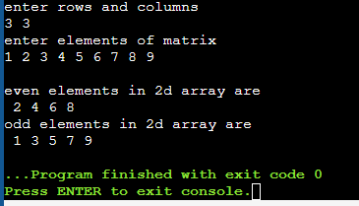

16)

Code:

#include<stdio.h>

int main()

{

int a[10][10],b[10][10],add[10][10],subtract[10][10],t1[10][10],t2[10][10];

int r,c;

int choice;

printf("enter rows and columns of matrices\n");

scanf("%d%d",&r,&c);

printf("enter elements of 1st matrix\n");

for(int i=0;i<r;i++)

{

for(int j=0;j<c;j++)

scanf("%d",&a[i][j]);

}

printf("enter elements of 2nd matrix\n");

for(int i=0;i<r;i++)

{

for(int j=0;j<c;j++)

scanf("%d",&b[i][j]);

}

printf("entr operation to be performed with the 2d matrices(add-1/subtract-2/transpose 1st matrix-3/transpose 2nd matrix-4");

scanf("%d",&choice);

switch(choice)

{

case 1:

for(int i=0;i<r;i++)

{

for(int j=0;j<c;j++)

{

add[i][j]=a[i][j]+b[i][j];

printf("%d\t",add[i][j]);

}

printf("\n");

}

break;

case 2:

for(int i=0;i<r;i++)

{

for(int j=0;j<c;j++)

{

subtract[i][j]=a[i][j]-b[i][j];

printf("%d\t",subtract[i][j]);

}

printf("\n");

}

break;

case 3:

for(int i=0;i<r;i++)

{

for(int j=0;j<c;j++)

{

t1[i][j]=a[j][i];

printf("%d\t",t1[i][j]);

}

printf("\n");

}

break;

case 4:

for(int i=0;i<r;i++)

{

for(int j=0;j<c;j++)

{

t2[i][j]=b[j][i];

printf("%d\t",t2[i][j]);

}

printf("\n");

}

break;

default:printf("enter corrrect value");

}

}

Output:

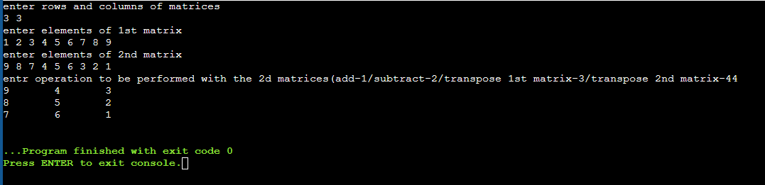

17)

Code:

#include<stdio.h>

int main()

{

int a[10][10],b[10][10],multiply[10][10];

int r1,c1,r2,c2;

printf("enter rows and columns of 1st matrix\n");

scanf("%d%d",&r1,&c1);

printf("enter elements of 1st matrix\n");

for(int i=0;i<r1;i++)

{

for(int j=0;j<c1;j++)

scanf("%d",&a[i][j]);

}

printf("enter rows and columns of 2nd matrix\n");

scanf("%d%d",&r2,&c2);

printf("enter elements of 2nd matrix\n");

for(int i=0;i<r2;i++)

{

for(int j=0;j<c2;j++)

scanf("%d",&b[i][j]);

}

if(c1!=r2)

printf("matrix multiplication is not possible");

else

{

for(int i=0;i<r1;i++)

{

for(int j=0;j<c2;j++)

{

multiply[i][j]=0;

for(int k=0;k<c1;k++)

{

multiply[i][j]+=a[i][k]*b[k][j];

}

}

}

for(int i=0;i<r1;i++)

{

for(int j=0;j<c2;j++)

{

printf("%d\t",multiply[i][j]);

}

printf("\n");

}

}

}

Output:

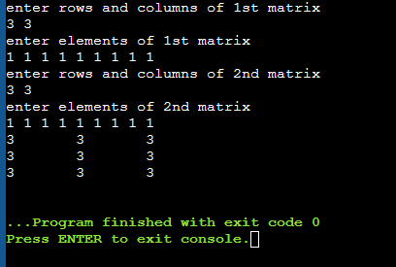

18)

Code:

#include<stdio.h>

int main()

{

int n1,n2,max,min;

printf("enter size of arr1 and arr2");

scanf("%d%d",&n1,&n2);

int n=n1+n2;

int a[n1],b[n2];

printf("enter elements of arr1");

for(int i=0;i<n1;i++)

{

scanf("%d",&a[i]);

}

printf("enter elements of arr2");

for(int i=0;i<n2;i++)

{

scanf("%d",&b[i]);

}

int k=0;

for(int i=n1;i<n;i++)

a[i]=b[k++];

printf("merged array in reverse form is\n");

for(int i=n-1;i>=0;i--)

printf("%d\t",a[i]);

}

Output:

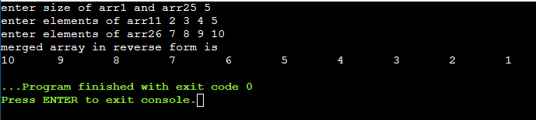

19)

Code:

#include <stdio.h>

int rev(int n);

int main()

{

int n,m;

printf("enter numb");

scanf("%d",&n);

m=rev(n);

printf("%d",m);

return 0;

}

int rev(int n)

{

static int rv=0;

int r=n%10;

if(n==0)

{

return;

}

else

{

rv=r+rv*10;

rev(n/10);

}

return rv;

}  
output:

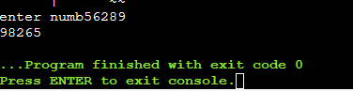

20)

Code:

#include<stdio.h>

int swap();

int n=10,m=20;

int main()

{

printf("before swapping values of m and n are %d and %d respectively\n",m,n);

swap(n,m);

printf("after swapping values of m and n are %d and %d respectively",m,n);

}

int swap()

{

int temp;

temp=n;

n=m;

m=temp;

}

Output:

